**IZOD TEST**

OBJECTIVES:  
To find the impact resistance of mild steel.

Apparatus used:

Impact Testing Machine

|  |  |
| --- | --- |
|  |  |

**STEP:➊** Test for friction loss is conducted by adjusting the pointer to 164 Joules and the hammer attached to the pendulum is released by operating the lever without keeping the specimen.

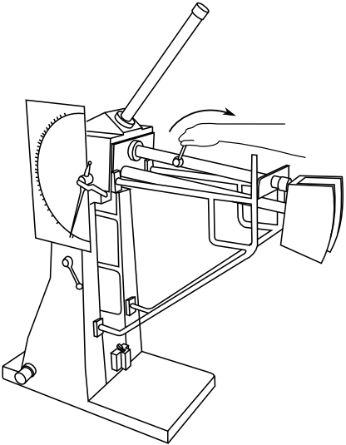

(SEE VIDEO: SHOW ANIMATION)

Loss of energy due to friction Ef=_____J

**STEP:** ➋ The Izod test specimen as per Indian Standards IS:3766-1977 is placed in position.

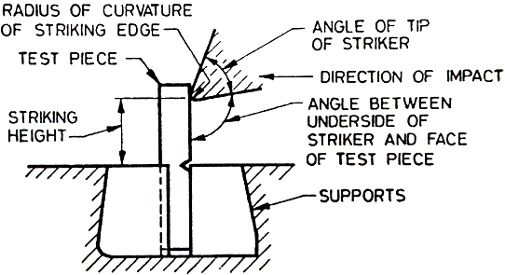

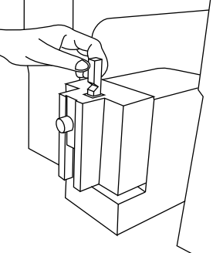

Source: IS:3766-1977

**STEP:** **➌** The pointer is adjusted to 164 Joules & the hammer attached to the pendulum is released by operating the lever. The hammer strikes against the specimen, breaks it and swings further and the energy to rupture is obtained from the pointer reading.

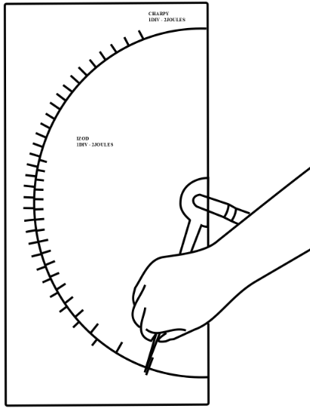

(SEE VIDEO: SHOW ANIMATION)

Total loss of energy during transit of Hammer ET =_____J

Energy for failure of specimen= ET -Ef=_____J